Question 1

**<https://youtu.be/gd9aTazw2kE>**

**Step 1:**

Login to Google cloud.

<https://console.cloud.google.com/>

Project🡪 New Project🡪Project Name(**Assignment2**)🡪Create(Under Organisation & Location iitj.ac.in)

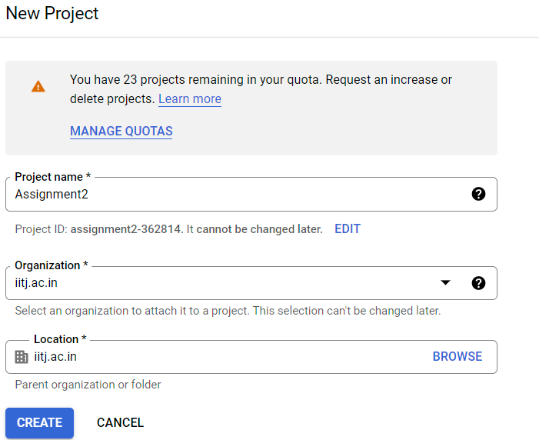

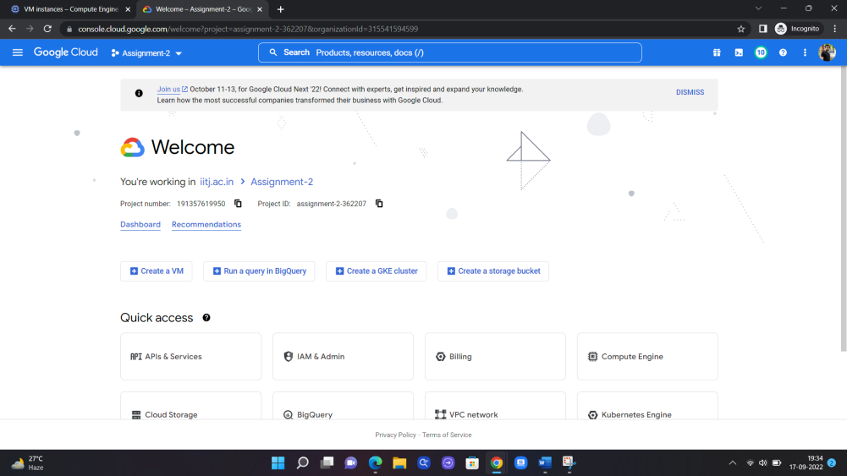

**Step 2:**

* Click the Navigation bar menu and select Compute engine🡪 VM Instances🡪 Create Instance
* Provide instance name as m20aie252-mdb
* Selected Region and zone as a default value(us-central1)
* In Machine configuration selected machine type as e2-medium(2 vCPU, 4GB Memory)
* Boot disk section I changed Operating System to ubuntu and version 20.04 LTS x86/64(10GB Size)
* In Firewall section checked allow http/https traffic both

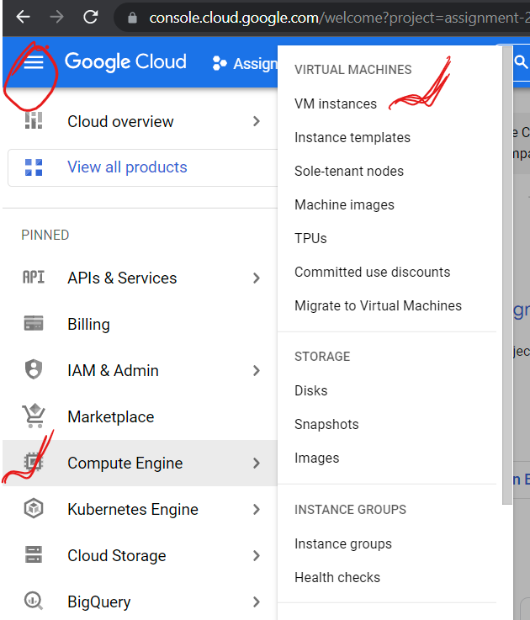

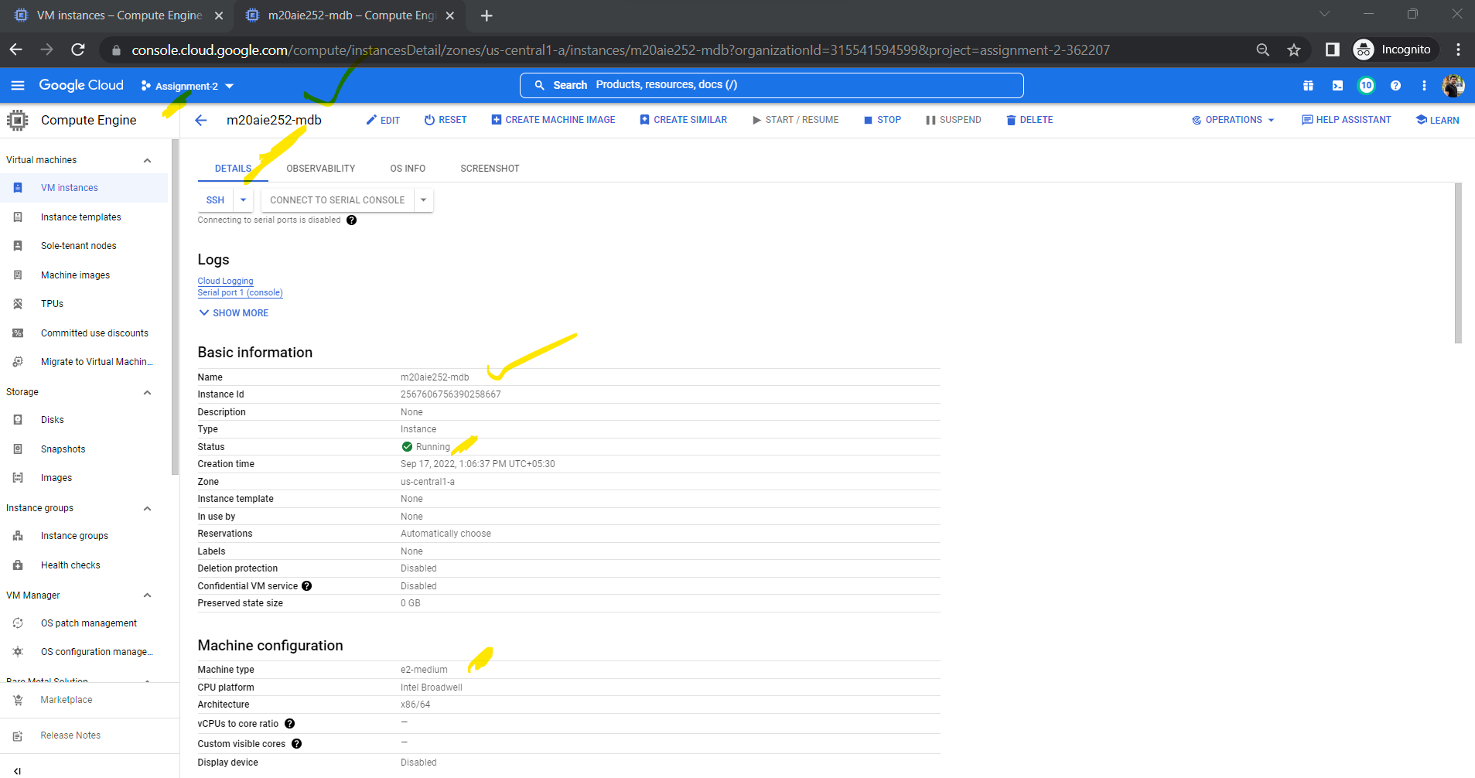

**Step 3:**

**Install MongoDB in linux VM**

* The 1st step is to install the prerequisite packages.

sudo apt install -y software-properties-common gnupg apt-transport-https ca-certificates

* To install the most recent mongodb

sudo apt install -y mongodb

wget -qO - https://www.mongodb.org/static/pgp/server-5.0.asc | sudo apt-key add -

output is : **Ok**

* Add apt repository to the directory **/etc/apt/sources.list.d**

echo "deb [ arch=amd64,arm64 ] https://repo.mongodb.org/apt/ubuntu focal/mongodb-org/5.0 multiverse" | sudo tee /etc/apt/sources.list.d/mongodb-org-5.0.list

* To add the local repository as we add the the mongodb latest package.(metapackages install)

sudo apt update

sudo apt install -y mongodb-org

* When the installation completed we can check the mongo db version by using –

mongod --version

* All the above steps I did inside SSH terminal

**Step 4:**

* This step is all about start and enable the mongodb what we installed above
* As we know by default mongodb services are disabled so we need to enable by using these below command

sudo systemctl status mongod

sudo systemctl start mongod

* To know the current version of the mongodb , port listening to and server url

mongo --eval 'db.runCommand({ connectionStatus: 1 })'

This returns the value of the mongodb internal connectionstatus.( 1 means ok)

* To check the default port and the services is running as expected:

sudo ss -pnltu | grep 27017

sudo systemctl enable mongod

**Step 4:**

This step is all about creating new user and database inside mongodb.

* To start or access the mongodb inside linux vm :

mongosh

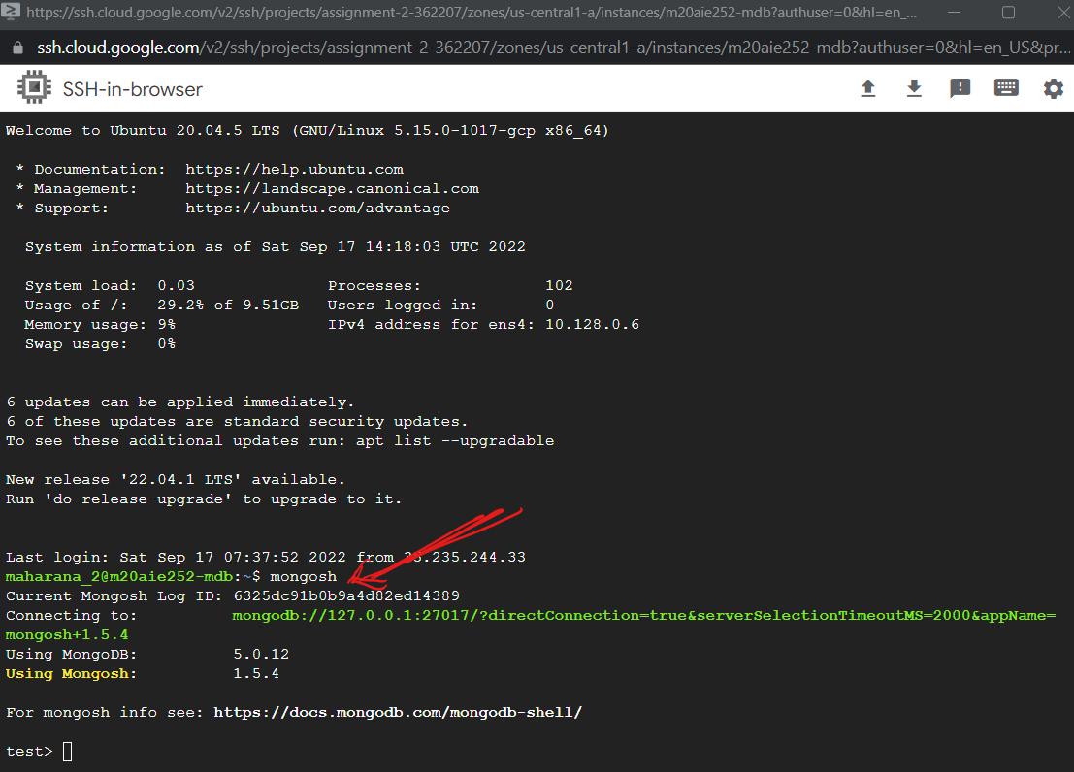

* At the beginning when I installed there are only 3 default databases are there inside mongo db as *admin, config and local*.

For checking existing databases

show dbs

To create a new database, we can use the command **use employees;**

* I created a user like this:

db.createUser(

{

user: "AdminCherry",

pwd: passwordPrompt(),

roles: [ { role: "userAdminAnyDatabase", db: "admin" }, "readWriteAnyDatabase" ]

}

)

* To enable the authentication

sudo nano /etc/mongod.conf

Here it opens the file mongod.conf.

To enable the security-

security:

authorization: enabled

then save changes and exit from the file CTRL + X .

Restart the mongo service by

sudo systemctl restart mongod

Then once again login to the mongo.

Mongosh

show dbs

mongosh "mongodb://password@external-ip-from-vm-mongo-ip-address:27017"

* For remote access to my personal PC:

I changed the port and bindIp as below

sudo nano /etc/mongod.conf

**# network interfaces**

**net:**

**port: 27017**

**bindIp: 0.0.0.0**

save changes from conf file and exit and restart once again.

sudo systemctl restart mongod

* To enable ufw from the remote machine I added the Ip as 0.0.0.0(default)

sudo ufw allow from 0.0.0.0 to any port 27017

* After that we need to reload like

sudo ufw reload

Step 5:

To access the mongo db remotely and listen to port 27017

* Installed the netcat

sudo apt install netcat

nc -zv 0.0.0.0 27017

Here output is like-

Connection to 0.0.0.0 27017 port [tcp/*] succeeded!

**Step 5:**

Inside firewall setting , create new firewall policy.

VPC Nework🡪 Create VPC Network

TCP : 27017

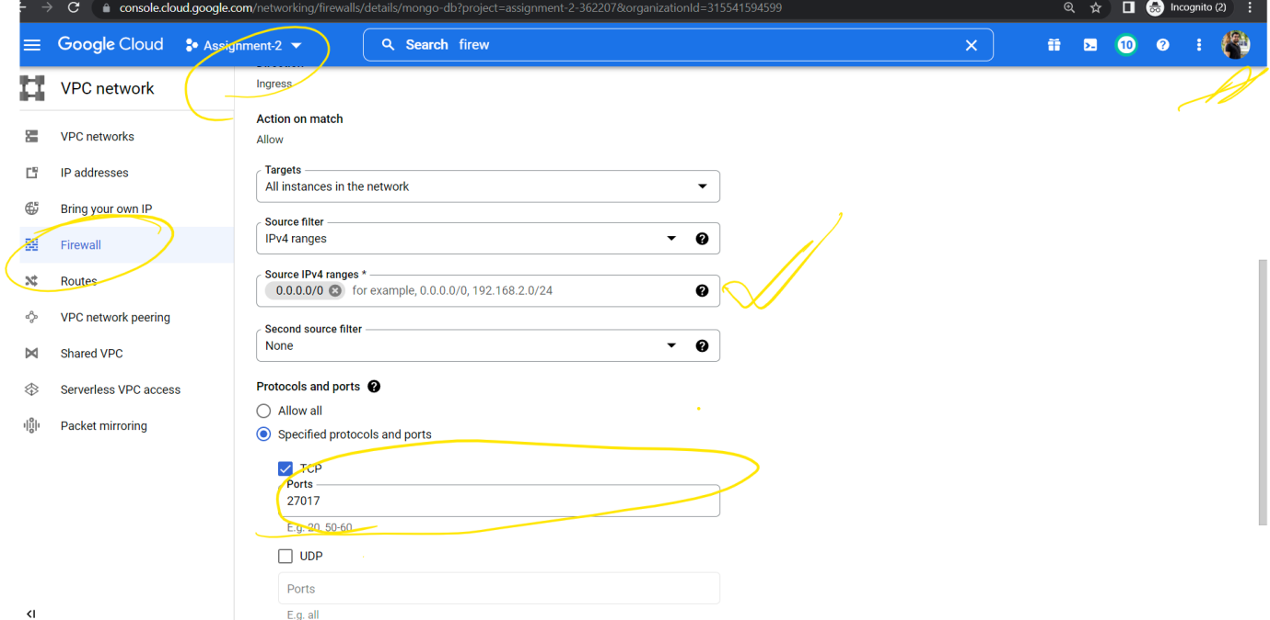

**Step 6:**

I installed **nosql booster for mongodb** client.

* New Connection🡪 Create new (External Ip address from VM)🡪Port 270171
* For authentication basic user name and password
* Created new db as test, collection(staff) and add some data.(for more details you can see my below images)

